LAB 4
Baltabayev Nuriman – 23B051013
Variant – 6
- mathematical model
ƒ(x) = 2x² + 5x + 3
P(x=0) = 0 P(x=1) = 1
- Analytical solution
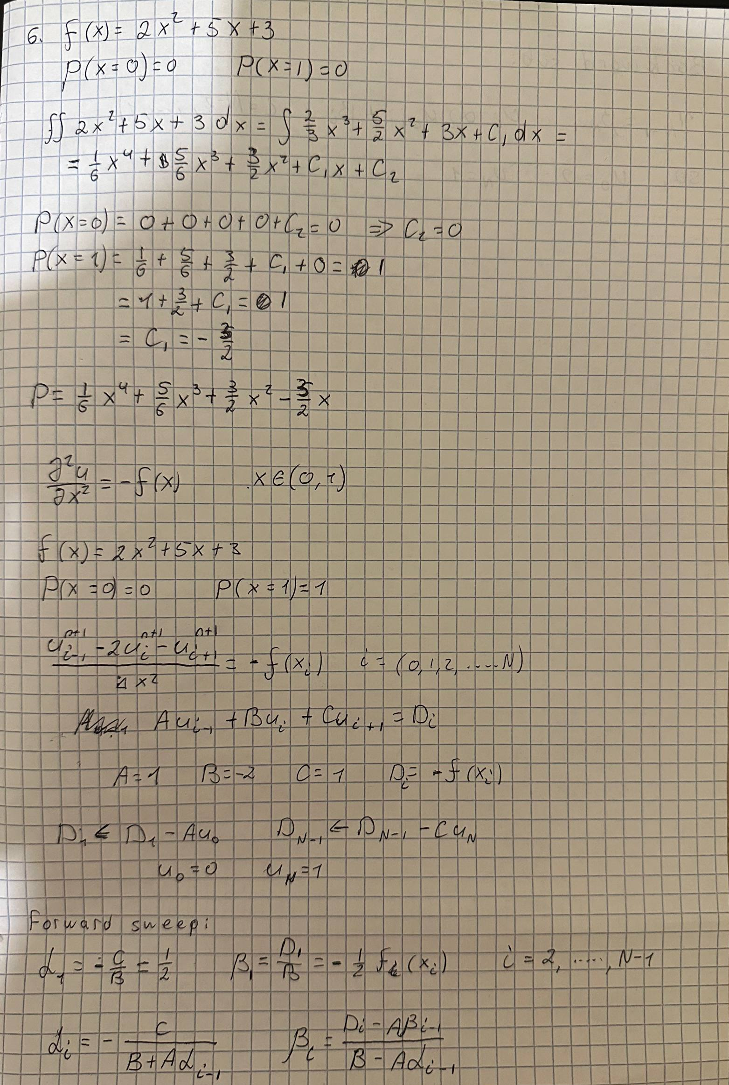

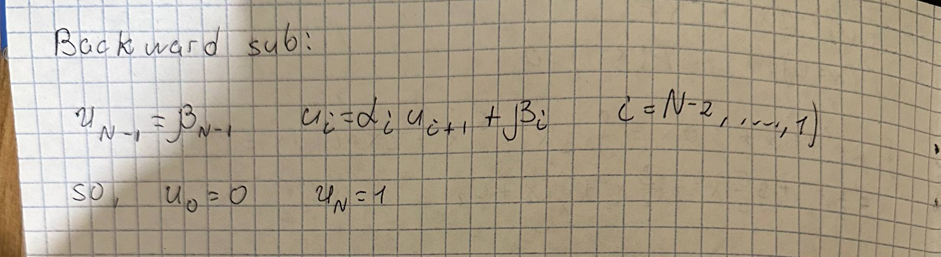
- Code implementation
- import numpy as np
- import matplotlib.pyplot as plt

- def f(x):
- return 2*x**2 + 5*x + 3

- def u_analytical(x):
- # u(x) = (1/6)x^4 + (5/6)x^3 + (3/2)x^2 - (3/2)x (solves u''=f with u(0)=0, u(1)=1)
- return (1/6)*x**4 + (5/6)*x**3 + (3/2)*x**2 - (3/2)*x

- def solve_poisson(n=100):
- A, B, C = 1.0, -2.0, 1.0
- h = 1.0/n
- x = np.linspace(0.0, 1.0, n+1)
- u0, uN = 0.0, 1.0

- # RHS for interior nodes
- D = (h**2)*f(x[1:-1])
- D[0] -= A*u0
- D[-1] -= C*uN

- # Forward sweep
- alpha = np.zeros(n-1)
- beta = np.zeros(n-1)
- alpha[0] = -C/B
- beta[0] = D[0]/B
- for i in range(1, n-1):
- denom = B + A*alpha[i-1]
- alpha[i] = -C/denom
- beta[i] = (D[i] - A*beta[i-1]) / denom

- # Back substitution
- u = np.zeros(n+1)
- u[0], u[-1] = u0, uN
- u[n-1] = beta[-1]
- for i in range(n-2, 0, -1):
- u[i] = alpha[i-1]*u[i+1] + beta[i-1]
- return x, u

- if __name__ == "__main__":
- n = 100
- x, u_num = solve_poisson(n)
- u_an = u_analytical(x)
- diff = u_an - u_num
- print(f"Max |error| = {np.max(np.abs(diff))}")
- print(f"L2 error = {np.sqrt(np.sum(diff**2)/len(diff))}")

- plt.figure()
- plt.plot(x, u_an, label="Analytical")
- plt.plot(x, u_num, linestyle="--", label="Numerical (Thomas)")
- plt.xlabel("x"); plt.ylabel("u(x)"); plt.title("Poisson 1D: Analytical vs Numerical")
- plt.legend()
- plt.savefig("poisson_comparison.png", dpi=160, bbox_inches="tight")
- plt.show()

4. Graph
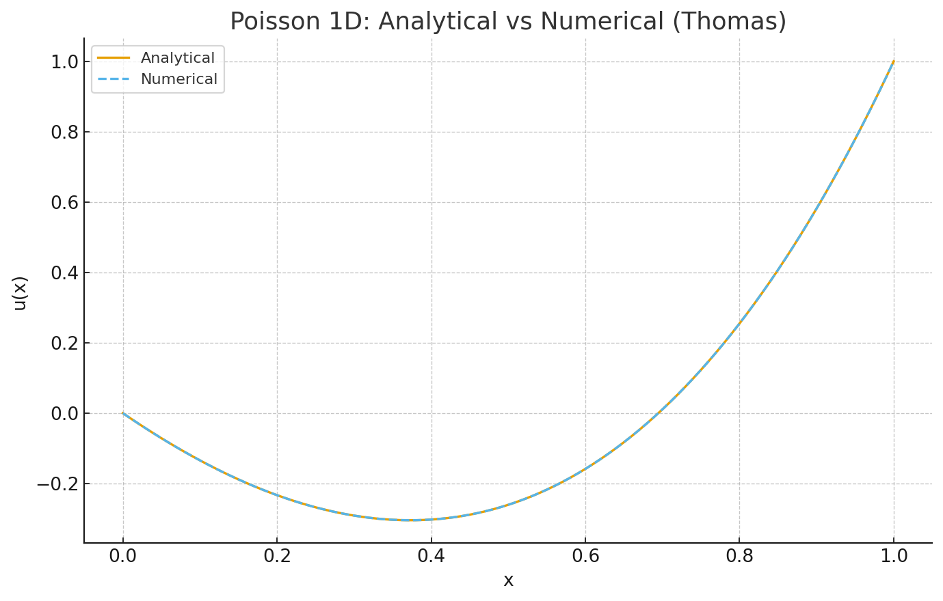
5. Difference
A=1, B=-2, C=1, D_i = h^2 f(x_i) with h=1/n.
alpha_1 = 0.5
beta_1 = -0.00015251
u_N = 1.0
Max |error| = 4.166666667249075e-06
L2 error = 3.0278017333543125e-06

6. Conclusion
The numerical solution matches the analytical polynomial very closely: the curves overlap in the plot, and the maximum pointwise error is $∼{10}^{-6}$ for
$N=100$. This confirms the correctness of the discretization $(A,B,C)=(1,-2,1)$. Increasing $N$would further reduce the already small error.

